

Table of contents:

- Story
- How to get started
- Controls
- Author

- Story

Jack is one of the students, who study the ancient art of Thang-kou-nou.
Thang-kou-nou is the ultimate martial art technique.
Jack will soon master the ancient technique
and he will keep the ancient tradition of martial arts going.

Jack's sensei, Ranzou Chi, is a master of all martial art techniques.
Ranzou Chi will be soon retiring
and Jack will be his last student.

Jack is coming to his last training before
mastering the technique.
But when Jack gets to temple he notices something...

...EVIL NINJAS!

2. How to get started

1. Main:

 This is Jack. You control him.

2. Collectables:

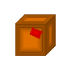 This is a box. It can contain meat, orb, nunchaku or it can be empty.

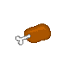 This is a piece of meat. Eat it and get some energy.

 This is an orb. It fills your mana.

 This is nunchaku. Collect them and shoot them.

3. Statusbar:

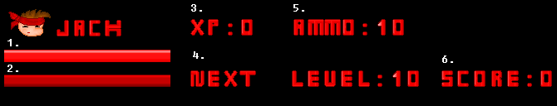

- Your energy bar. If it reaches zero, you’ll fail.
- Your mana bar. To do a special, you must have some mana.
- Your current experience points.
- Shows the number of experience points needed for next level.
- Shows the number of your nunchakus.
- Your current score.

Get XP by killing enemies.

When you got enough points,
you will level up.

Levels are needed to make special combos.

4. Controls

You can set your own keys in the options,
but here are the default settings:

1. Moving:

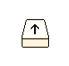 Move up

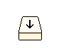 Mode down

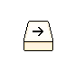 Move right

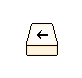 Move left

2. Moves:

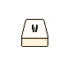 Load mana

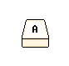 Punch

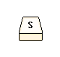 Headbutt

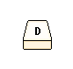 Kick

 Jump

3. Other

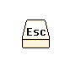 Press to quit/go to menu

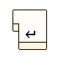 Press Enter to accept/skip intro.

4. Author

You can give this game to your friends or so,
but please tell who made it.

This game is created by Tuukka Virtanen.
Assistance by Erkka Virtanen.

Main programming by Tuukka Virtanen.
Main design by Tuukka Virtanen.

Testing by
Tuukka Virtanen,
Erkka Virtanen
and Henrik Virtanen.

Most of the game musics by Mika Lehtisare.
Visit his website:

http://www.blueskull.cjb.net/

Some musics by Henrik Virtanen.

Email us:

tuukkav@cedunet.com
wirtanen@cedunet.com

Visit our website:

http://www.virtanen.urli.net

All rights reserved.

Tuukka Virtanen Copyright (c) 2005

